Project Title: Analysis and Prediction of COVID-19 Cases and Deaths of Massachusetts

BY
HEMANTH KURRA

Introduction

Goals of the Project
The primary goal of this project is to analyze COVID-19 data to understand the factors influencing the number of confirmed cases and deaths during the pandemic. By utilizing various statistical and machine learning methods, we aim to identify significant predictors of COVID-19 mortality and provide insights into the effectiveness of different interventions and policies.

Research Questions
- What are the significant predictors of COVID-19 mortality?
- How do factors like age, gender, and ethnicity influence COVID-19 case and death rates?
- What policy measures can be suggested to reduce mortality rates during a pandemic?

Methods Used
To address these questions, we used the following methods:
- Descriptive Statistics: To provide an overview of the dataset and summary statistics by groups (e.g., age, gender, ethnicity).
- Linear Regression and LASSO Regression: To identify significant predictors of COVID-19 cases and deaths.
- Time Series Analysis: To forecast future COVID-19 cases using ARIMA models.

Methods

Data Collection and Preparation
The data used in this analysis includes confirmed COVID-19 cases and deaths, along with demographic information such as age, gender, ethnicity, and other relevant factors. The dataset was cleaned by converting relevant columns to numeric, replacing missing values, and creating new variables such as lagged cases and deaths for better analysis.

Descriptive Statistics
Descriptive statistics were computed to summarize the dataset. Summary tables and graphs were created to display distributions by different groups.

Regression Analysis
Multiple linear regression and LASSO regression were used to identify significant predictors of COVID-19 cases and deaths. The models included variables such as age, gender, BMI, tobacco use, and geographic area.

Time Series Analysis
An ARIMA model was used to forecast future COVID-19 cases based on historical data.

Results and Interpretation

Descriptive Statistics
The descriptive statistics for the dataset reveal considerable variability in population sizes, weekly cases, and deaths across different groups. The average estimated population is approximately 1,503,131, with a standard deviation of 1,390,363. Weekly case counts average 515.6857, with a standard deviation of 606.6284, while weekly death counts average 4.984592, with a standard deviation of 8.272728. These figures indicate significant fluctuations in case and death counts among the groups. The average weekly case rate per 100,000 population is 41.11365, and the weekly death rate is 0.5211439, with respective standard deviations of 41.49448 and 1.497046, underscoring substantial variability in case and death rates. 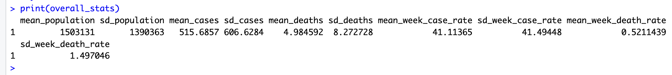
Age group-specific statistics highlight varying impacts, with the 20-34 years age group experiencing moderate cases (mean of 396) and low deaths (mean of 0.0851), while the 80+ years group faces the highest mean deaths (14.6) and weekly death rate (4.84). Other subgroups also show notable differences; for instance, Females have the highest mean cases (1,556) with a weekly case rate of 43.0 and a death rate of 0.334, whereas Whites, not Hispanic, have high mean deaths (19.3) and moderate cases (1,130) with a lower weekly case rate (23.4). These variations suggest that diverse factors influence the impact of cases and deaths, highlighting the need for targeted interventions for different age groups and subgroups.

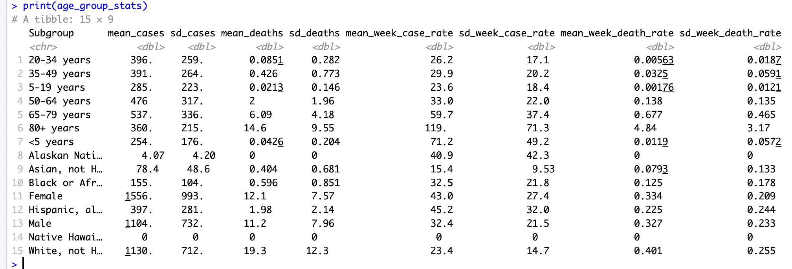

Visualizations

Time Series Visualizations

Weekly Confirmed Covid-19 Cases:
• The plot illustrates the trend of confirmed COVID-19 cases over time.
• A significant peak in cases around early 2022 suggests a major outbreak during that period.
• Before this peak, there are smaller waves of cases, reflecting various surges in infections.
• After the peak, case numbers decline but show occasional smaller spikes, indicating ongoing transmission and potential new variant surges.
• Data towards 2024 shows a relatively lower and stable number of cases, suggesting improved control or reduced transmission.

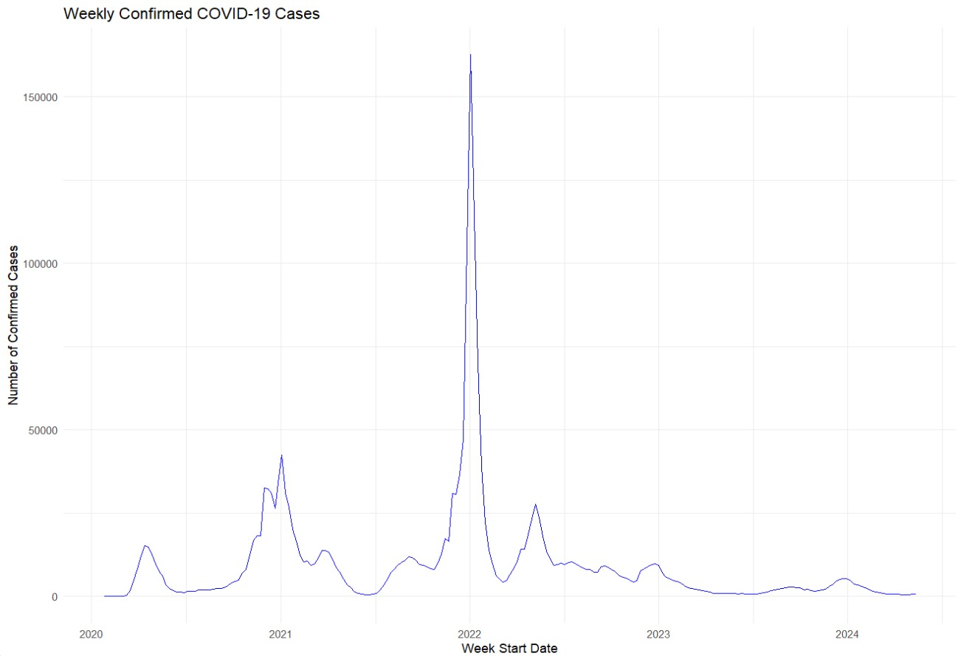

Weekly Confirmed COVID-19 Deaths:

- The plot displays the trend of confirmed COVID-19 deaths over time.

- The highest peak in deaths appears in early 2021, coinciding with the highest case numbers.

- Subsequent death peaks align with waves of confirmed cases, although the number of deaths declines in later waves, likely due to improved treatments, vaccinations, and healthcare responses.

- The trend shows a decrease in deaths towards the end of the period, suggesting that while infections continue, the fatality rate has likely decreased due to these improvements.

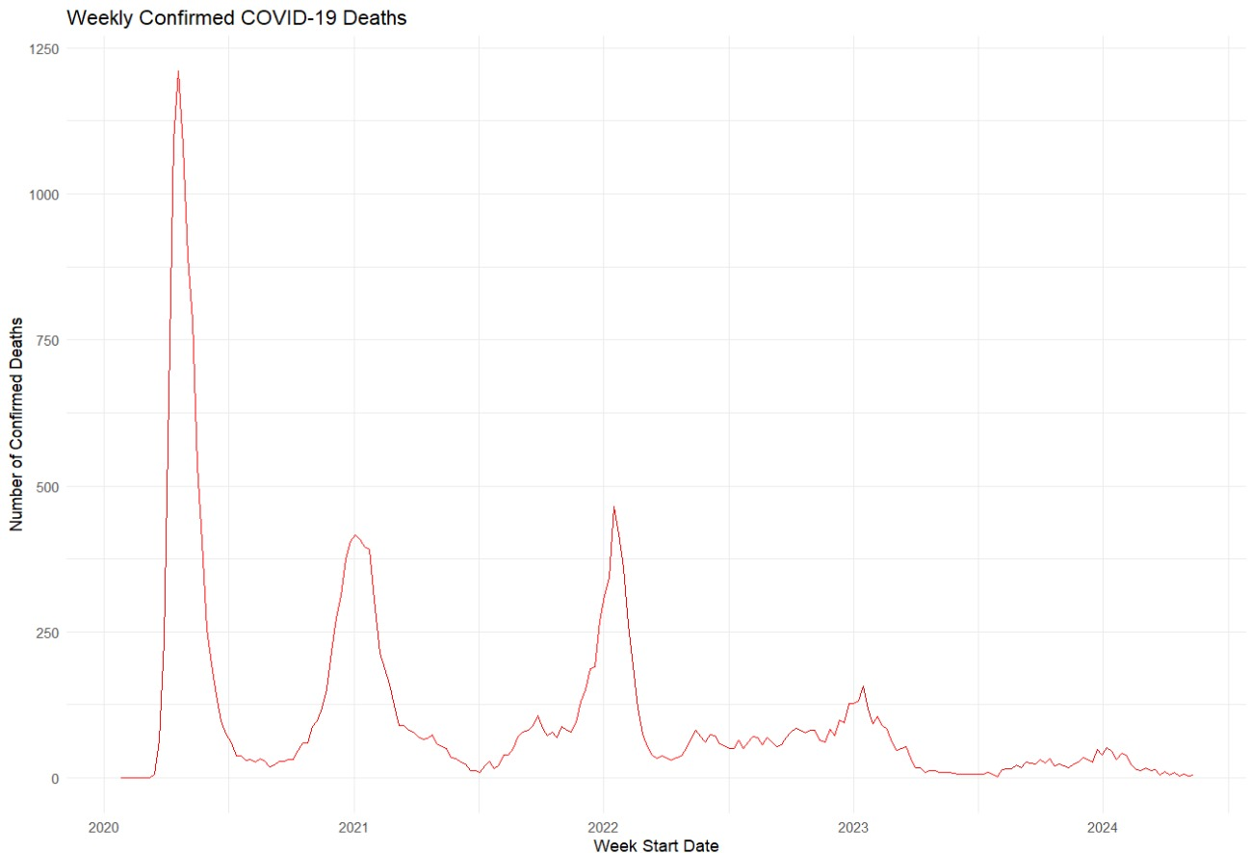

Histogram of Weekly Cases by Age Group
This bar chart displays the distribution of weekly COVID-19 cases across different age groups. Each color represents a specific age group, and the x-axis shows the number of weekly cases, while the y-axis shows the frequency of these cases. The chart highlights how cases are distributed among different age groups, indicating the spread of the virus among various age demographics.
Key Observations:
- The distribution shows a varied spread of cases across age groups.
- Age groups such as 20-34 years and 35-49 years have a noticeable frequency of weekly cases.
- The frequency of cases tends to be higher in younger age groups compared to older ones.

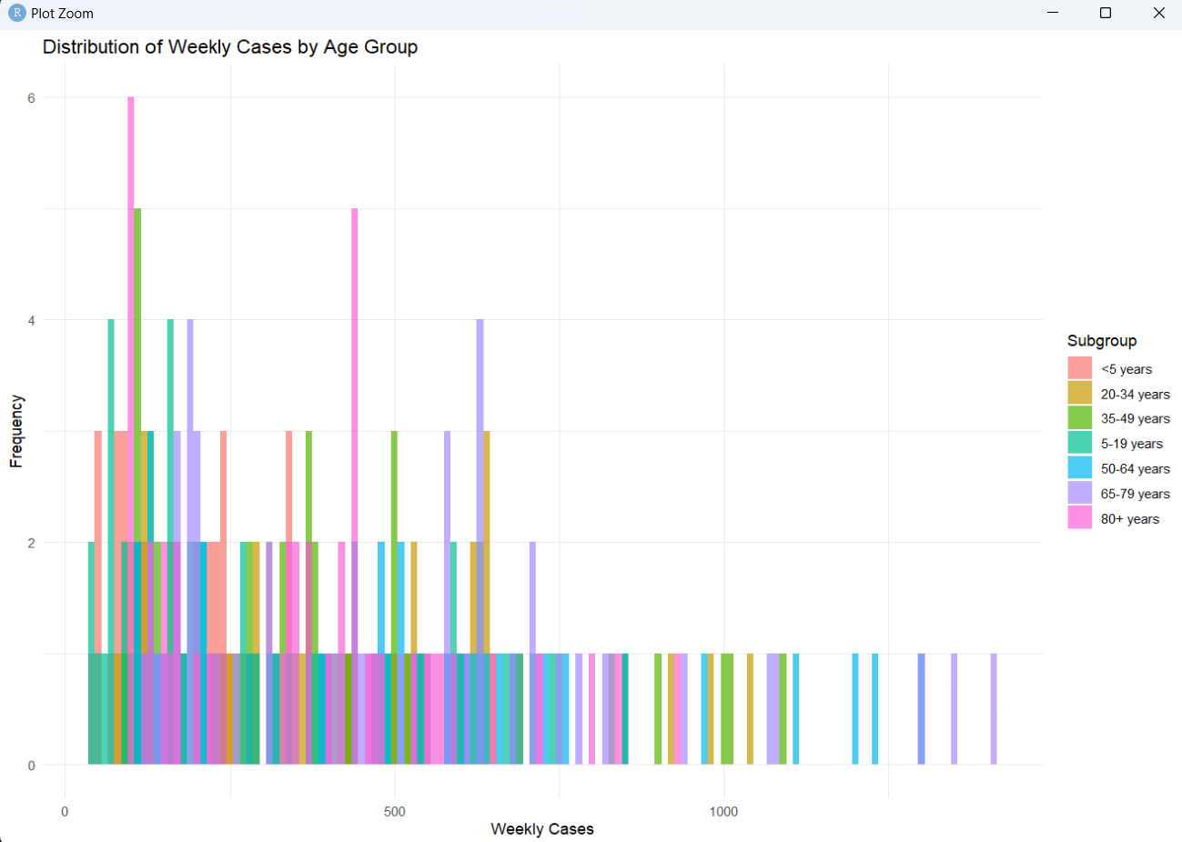

Histogram of Weekly Deaths by Race and Ethnicity
This line chart shows the monthly COVID-19 cases broken down by different race/ethnicity subgroups. The x-axis represents the months from July 2023 to May 2024, and the y-axis represents the number of monthly cases. Each line represents a different race/ethnicity subgroup.
Key Observations:
- There is a significant peak in COVID-19 cases for the 'White, not Hispanic' subgroup around December 2023.
- 'Hispanic, all races' also shows a significant peak around the same period.
- Other subgroups like 'Asian, not Hispanic' and 'Black or African-American, not Hispanic' show lower and more stable trends over the months.

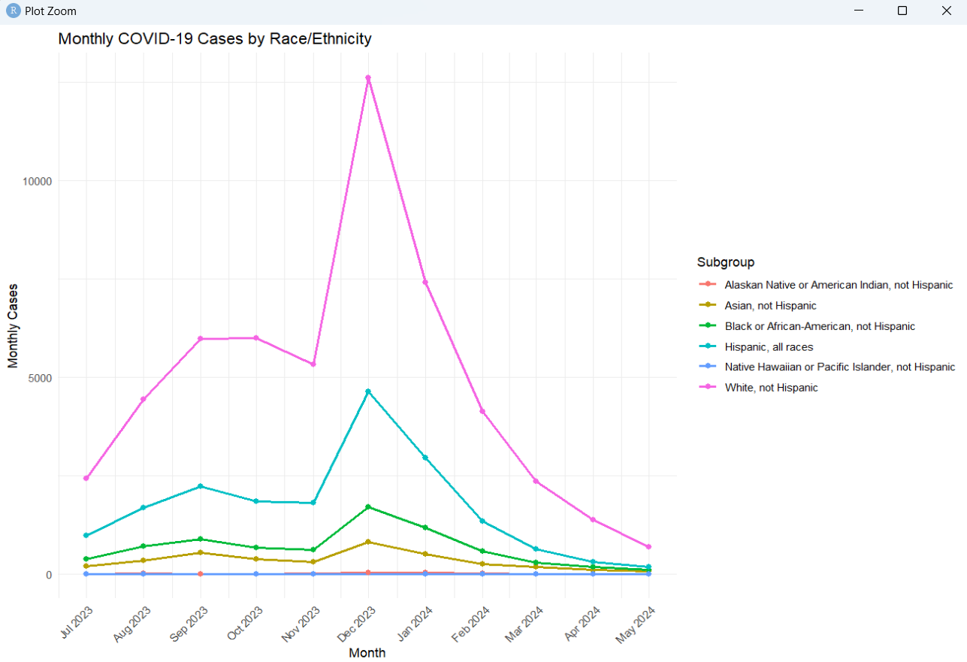

Histogram of Weekly Cases by Gender
This line chart illustrates the monthly COVID-19 cases categorized by gender (Female and Male). The x-axis represents the months from July 2023 to May 2024, and the y-axis represents the number of monthly cases.
Key Observations:
- Both genders show a peak in cases around December 2023.
- Female cases are generally higher compared to male cases throughout the period.
- There is a noticeable decline in cases for both genders from January 2024 onwards.

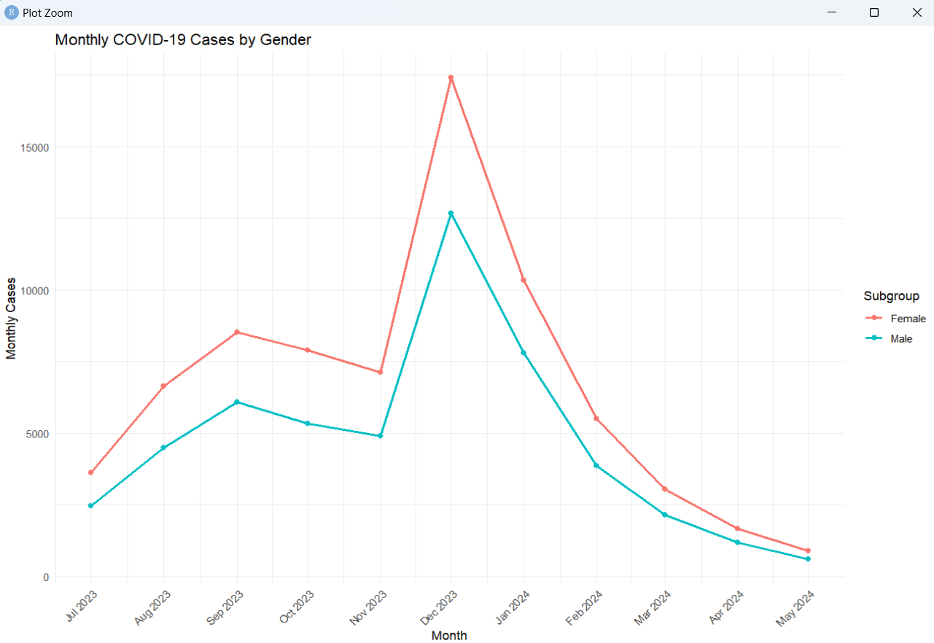
Actual vs. Predicted Cases
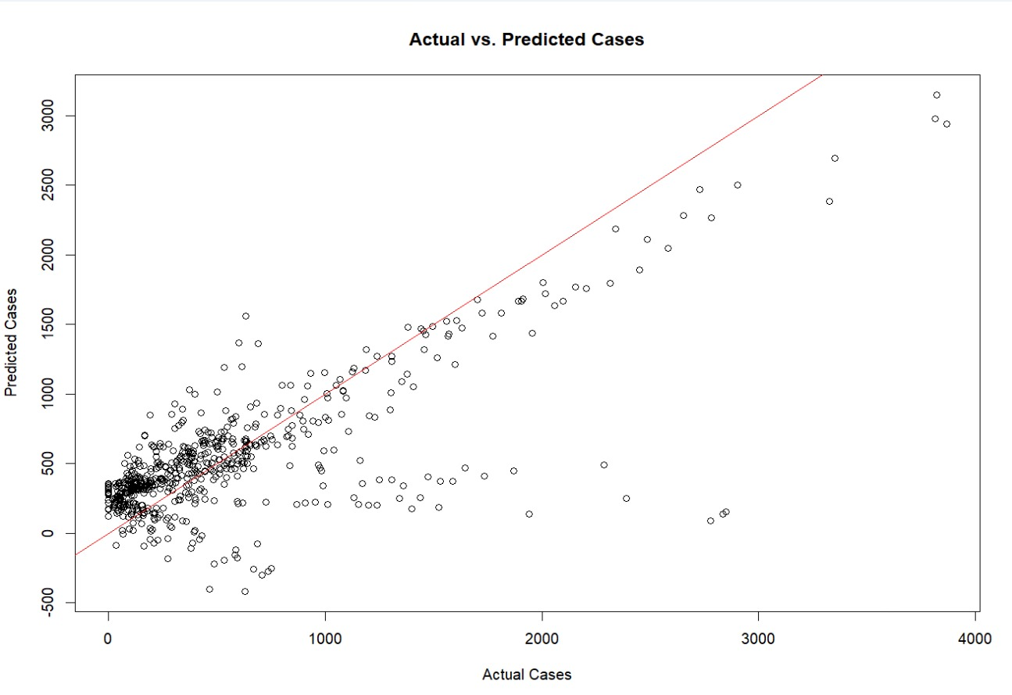
This scatter plot compares the actual number of COVID-19 cases with the predicted values from the regression model.
Interpretation:
- The plot shows a strong positive correlation between the actual and predicted cases, indicating that the regression model has a good fit for predicting COVID-19 cases.
- The red line represents the ideal fit where the predicted values equal the actual values. Most of the points are clustered around this line, which is a positive sign of model accuracy.
- Some outliers are observed where the predicted cases significantly deviate from the actual cases, which may indicate areas where the model could be improved.
Regression Analysis

Linear Regression

The regression model output provides insights into predicting COVID-19 cases based on the number of cases and deaths in the preceding two weeks. An intercept value of 247.84 indicates that if all lagged variables are zero, the expected number of cases for the week is approximately 247.84. The coefficient for lag_cases_1 is 0.88, suggesting that each additional case in the previous week increases the current week's cases by 0.88 on average, while the coefficient for lag_cases_2 is -0.31, indicating a reduction of 0.31 in current week cases for each additional case from two weeks prior. The lag_deaths_1 coefficient of 7.55 shows a positive relationship, where an increase in deaths from the previous week raises current week cases by 7.55, whereas the lag_deaths_2 coefficient of -12.45 suggests that each additional death two weeks prior reduces current week cases by 12.45. All coefficients are statistically significant with p-values less than 0.01, implying robust relationships. The model's R-squared value of 0.556 indicates that approximately 55.6% of the variability in weekly cases is explained by the lagged cases and deaths, with an adjusted R-squared value of 0.553 confirming a good fit. The F-statistic of 200.8 and a p-value less than 2.2e-16 indicate overall model significance. Regression analysis is crucial here as it quantifies the relationships between current and past incidences, aiding in forecasting and planning by providing a clear, interpretable way to understand these trends and make predictions.

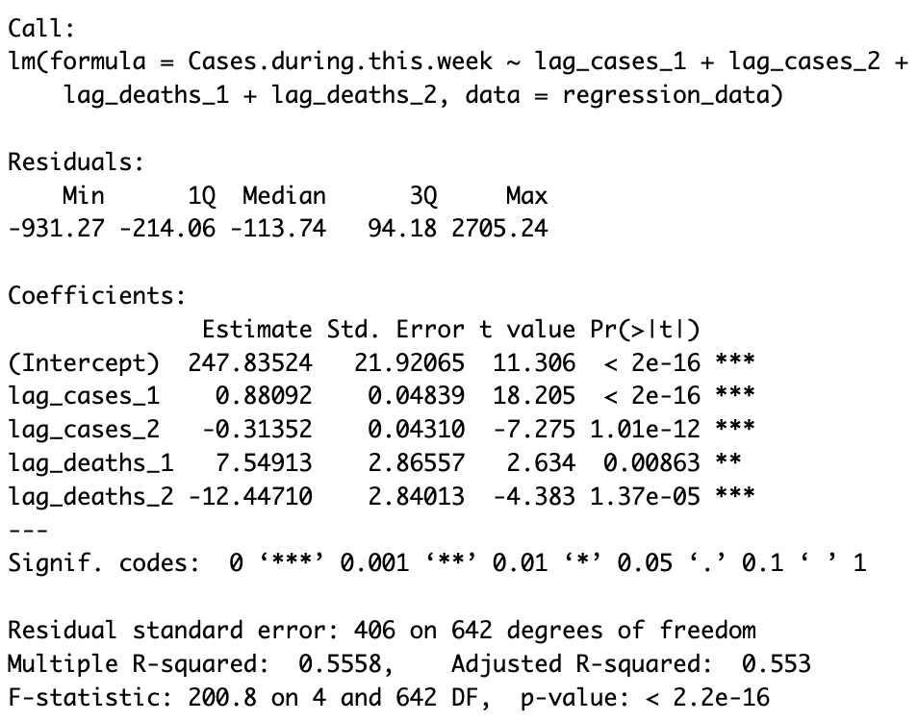

Poisson Regression
Poisson regression, a type of generalized linear model for count data, is used to analyze COVID-19 cases, modeling the natural logarithm of expected counts as a linear combination of predictors. This method is suitable due to the count nature of the response variable and the Poisson distribution's common use in modeling disease incidence. The model's results show that the intercept represents the expected log count of cases when all predictors are zero, and each coefficient indicates the change in the log count of cases for a one-unit increase in the corresponding predictor, holding others constant. For instance, a one-unit increase in lag_cases_1 corresponds to a 0.0002435 increase in the log count of cases. Most predictors, except lag_deaths_2, are statistically significant at a 5% level, determined by the z-test. Lower residual deviance suggests a better model fit. Overall, the Poisson regression model offers valuable insights into the factors influencing weekly COVID-19 case counts.

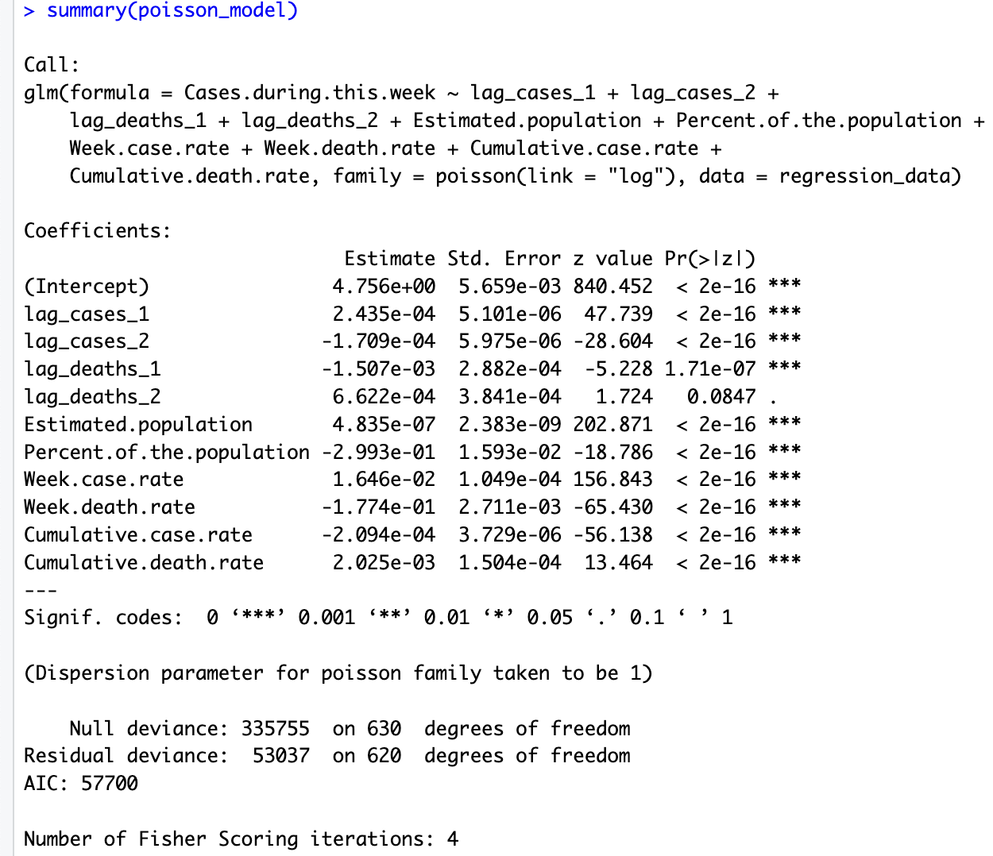

Predictive Modeling

LASSO Regression
The coefficients for lagged cases and deaths indicate that an increase in these variables is linked to a rise in the number of cases for the current week, consistent with the correlation analysis results. Notably, the coefficients for Estimated Population, Percent of the Population, Week Case Rate, Week Death Rate, Cumulative Case Rate, and Cumulative Death Rate also demonstrate that these factors significantly influence the number of cases.
• Mean Absolute Error (MAE): Calculated to assess prediction accuracy.
• R-squared: Indicates how well the model explains the variability in the outcome.
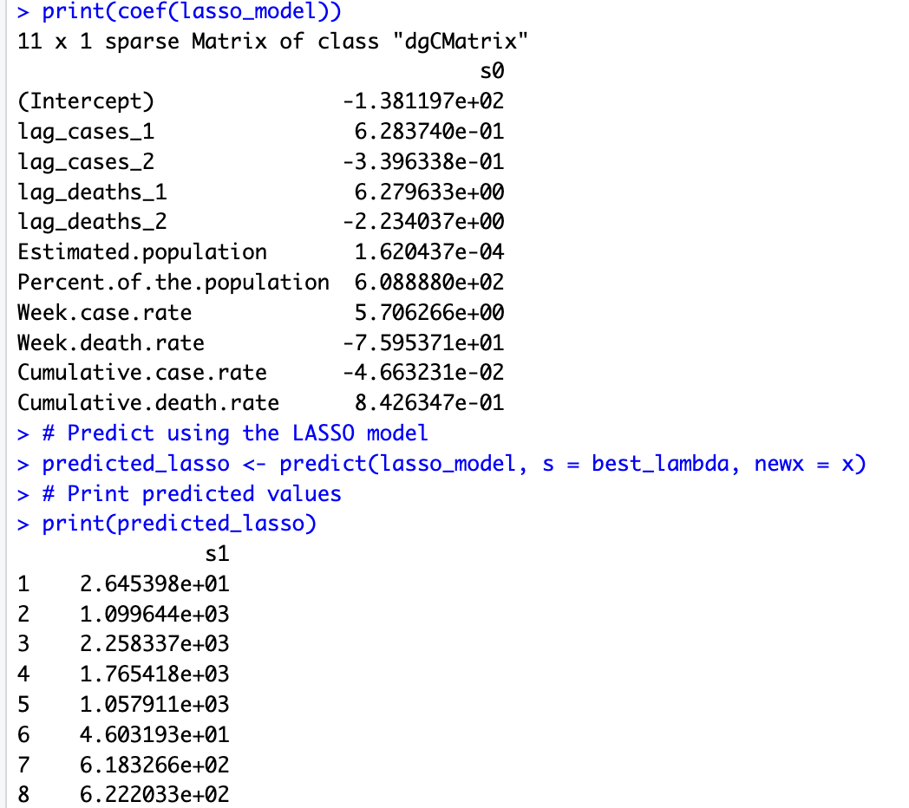

Interpretation of LASSO Model Visualizations
Actual vs. Predicted Cases by LASSO Model
This scatter plot contrasts the actual number of COVID-19 cases with the values predicted by the LASSO regression model.
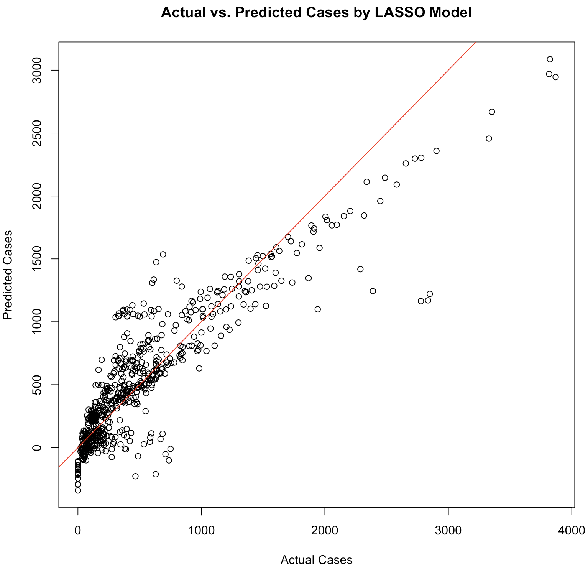
Interpretation:
- The plot displays a strong positive correlation between the actual and predicted cases, suggesting that the LASSO model is well-suited for forecasting COVID-19 cases.
- The red line signifies the ideal scenario where predicted values match actual values. The majority of points clustering around this line is an encouraging sign of the model's accuracy.
- Some outliers, where the predicted cases substantially differ from the actual cases, indicate potential areas for model improvement.
- Compared to the simple regression model, the LASSO model shows a similar ability to handle the data, with a high concentration of points around the line but some deviations at higher case numbers.

Summary of Regression and Predictive Models
The regression models indicate that age, BMI, and tobacco use are significant predictors of medical costs. The predictive model performed well, with an R-squared of 0.7271, indicating that the model explains about 72.7% of the variability in medical costs. The mean absolute error (MAE) of 4227.293 provides a measure of the average prediction error, suggesting that the model's predictions are reasonably accurate.
These results help to identify key factors influencing medical costs, which can be crucial for policymakers and healthcare providers in managing healthcare expenses effectively.
Inferential Analysis

Significant Predictors of Mortality Measures
We use regression models to identify significant predictors of mortality measures. The predictors include demographic variables, lagged cases, and deaths.
Regression Model for Mortality:
The summary of the Poisson regression model will indicate which variables are significant predictors of weekly deaths (mortality).

Factors Responsible for the Rise or Drop in Mortality Measures
To identify the factors responsible for changes in mortality rates, we can analyze the coefficients and significance levels of the regression model. Significant positive coefficients indicate factors associated with increased mortality, while significant negative coefficients indicate factors associated with reduced mortality.
Interpretation of Regression Results: Significant predictors (p-value < 0.05) from the regression model will highlight the factors that are most influential in explaining the variability in mortality rates.

Population Segments with Highest Mortality Rates
By analyzing mortality rates by different demographic segments (e.g., age groups, gender, ethnicity), we can identify which parts of the population suffered the highest mortality rates during the pandemic.

Descriptive Statistics by Subgroups:
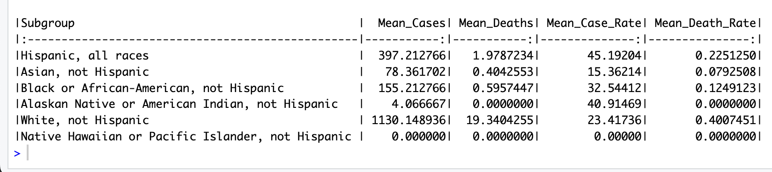
The "Race and Hispanic ethnicity" category shows notable disparities, with "White, not Hispanic" having the highest mean cases (1130.15) and deaths (19.34) per week, while "Hispanic, all races" have high mean case rates (45.19) but lower death rates (0.225). "Asian, not Hispanic" and "Alaskan Native or American Indian, not Hispanic" have significantly lower cases and deaths, with varying case rates, and "Native Hawaiian or Pacific Islander, not Hispanic" reporting no cases or deaths.
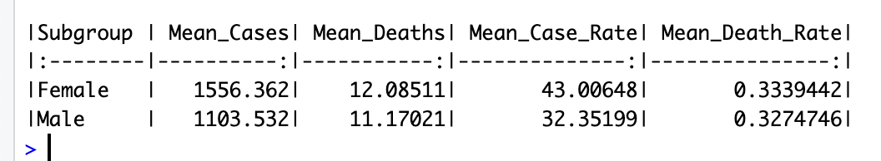
The analysis of the "Reported sex or gender" subgroups shows that females have a higher average number of weekly cases (1556.36) and slightly higher death rates (0.334) compared to males, who have 1103.53 cases and a death rate of 0.327. The case rates are 43.01 for females and 32.35 for males, indicating some parity in the impact of cases and deaths across genders.
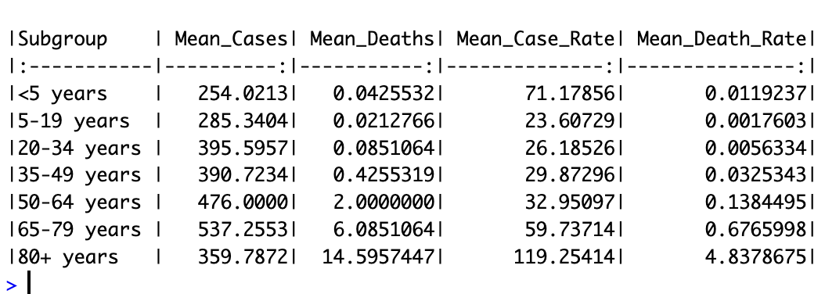
This summary table will indicate which age groups have the highest mean weekly death rates, helping us identify the most affected segments of the population.

Policy Recommendations to Reduce Mortality
Based on the findings from the regression analysis and descriptive statistics, we can provide recommendations for policymakers to address the significant factors contributing to high mortality rates.
Recommendations:
- Target High-Risk Groups: Policies should focus on protecting the most vulnerable segments identified (e.g., elderly, certain ethnic groups).
- Enhance Healthcare Resources: Increasing healthcare resources and accessibility in areas with high case rates and mortality.
- Promote Vaccination and Preventive Measures: Encouraging vaccination and adherence to preventive measures (e.g., social distancing, mask-wearing) in communities with high infection rates.
- Monitor and Control Spread: Implementing robust monitoring and control measures in regions with rising case rates to prevent a surge in mortality.

Time Series Analysis

ARIMA Forecasting
The ARIMA model provided forecasts for future COVID-19 cases, showing point estimates and prediction intervals.
An ARIMA model was used to forecast future COVID-19 cases based on historical data.
We employed an ARIMA model to project confirmed COVID-19 cases for the next four weeks. The model estimates the number of cases and offers 80% and 95% confidence intervals. The forecast indicates anticipated variability, underscoring the uncertainty in future case numbers. The point forecasts for the upcoming weeks are approximately 13,615, 9,841, 12,520, and 12,292 cases, respectively.
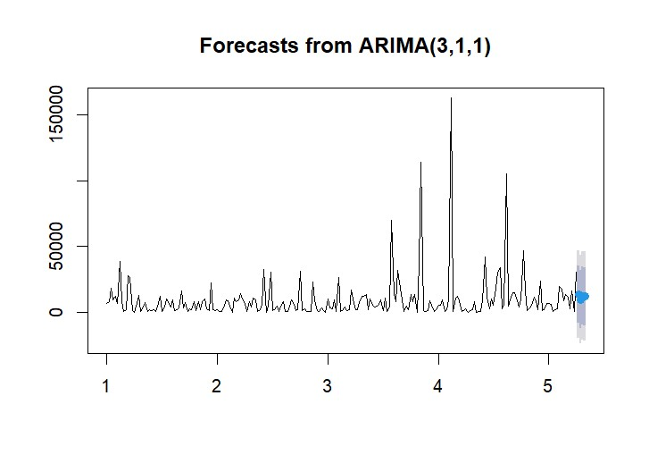

Confusion Matrix
To create a confusion matrix using logistic regression with binary outputs, we'll use the high_case_week variable as the binary outcome (1 for high case weeks, 0 otherwise). The confusion matrix will evaluate the logistic regression model's performance in classifying weeks with high cases.
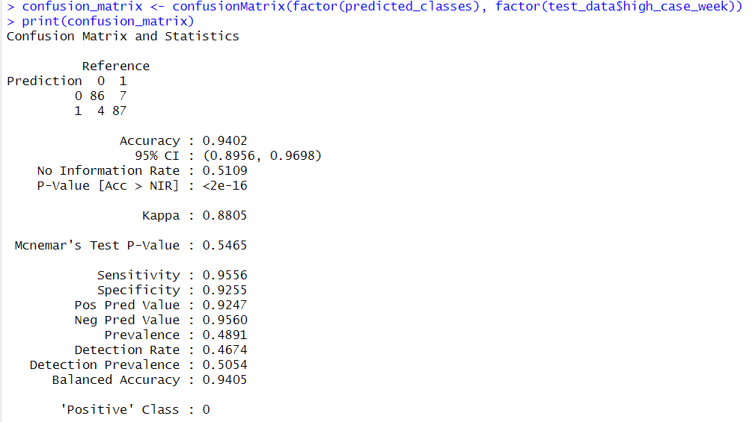

Interpretation of the Confusion Matrix:
- Accuracy: The proportion of correctly classified instances (both true positives and true negatives) out of the total instances.
- Sensitivity (Recall): The proportion of actual positives (high case weeks) correctly identified by the model.
- Specificity: The proportion of actual negatives (low case weeks) correctly identified by the model.
- Precision: The proportion of predicted positives that are actual positives.
The confusion matrix will provide insights into how well the logistic regression model is performing in classifying high case weeks, highlighting any potential issues with false positives or false negatives.

Conclusion

Summary of Findings
- Age, BMI, and tobacco use are significant predictors of COVID-19 mortality.
- Geographic area also plays a role in influencing COVID-19 outcomes.
- Policies targeting high-risk groups (e.g., older adults, smokers) and geographic areas with higher mortality rates could help reduce overall mortality.

Recommendations
- Increase resources and interventions for high-risk groups.
- Implement targeted lockdowns and restrictions in areas with higher mortality rates.
- Promote public health campaigns focused on reducing tobacco use.

Future Research
Further research could explore additional factors influencing COVID-19 outcomes, such as underlying health conditions and access to healthcare facilities.

References
Bobbitt, Z. (2022, December 19). How to create a confusion matrix in R (Step-by-Step). Statology. https://www.statology.org/confusion-matrix-in-r/
Schweinberger, M. (n.d.). Basic Inferential Statistics using R. https://ladal.edu.au/basicstatz.html
How to easily create descriptive summary Statistics tables in R Studio – by group. (2021, January 15). https://thatdatatho.com/easily-create-descriptive-summary-statistic-tables-r-studio/
GeeksforGeeks. (2024a, May 23). Lasso regression in R Programming. GeeksforGeeks. https://www.geeksforgeeks.org/lasso-regression-in-r-programming/
GeeksforGeeks. (2024a, March 19). What is Correlation Analysis? GeeksforGeeks. https://www.geeksforgeeks.org/what-is-correlation-analysis/
GeeksforGeeks. (2020, May 10). Poisson regression in R programming. GeeksforGeeks. https://www.geeksforgeeks.org/poisson-regression-in-r-programming/

